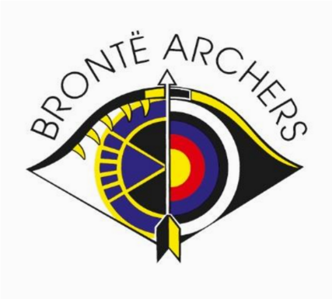
Bronte Archers Membership Form 2023/2024

APPLICATION FOR RENEWAL OF FULL MEMBERSHIP

Mr / Mrs / Miss / Other*………………First Name.................................... Surname…………………………………. Gender: Male / Female Is your gender the same as the sex you were registered at birth? Yes / No
D.O.B (Required)…….…………………………………. Nationality…………………………………………………….
Address ……………………………………………………………………...…………….………….…………………….
………………………………………………………………………………………………………………………………..
Post Code ………………….……...…….…. Telephone Number ………………………………………………….
E-Mail Address (Required………………………………………...………………...………………………..................
Bow Style ………………………. AGB Number (If known) ………………...........................................................
Category of Membership applied for: (Please Circle) 25 or over 18-24 Junior Disabled
I agree to be bound by the rules of the AGB, its organisations and the rules and constitution of Bronte Archers.

When you become a member of or renew your membership with Bronte Archers you will automatically be registered as a member of Archery GB and the relevant County and Region. We will provide Archery GB with your personal data which they will use to enable access to an online portal for you (https://agb.sport80.com) which, amongst other things, allows you to set and amend your privacy settings. If you have any questions about the continuing privacy of your personal data when it is shared with Archery GB, please contact gdpr@archerygb.org.

Would you like to hear from Archery GB about the latest news including the quarterly magazine?
If so, please tick below to let us know how you would like to hear from Archery GB

- AGB Communications Yes [ ] No [ ]
- Volunteers Ezine Yes [ ] No [ ]
- AGB Archery UK Magazine Yes [ ] No [ ]
- Members Ezine Yes [ ] No [ ]

The details you provide will be used to add to Bronte Archer’s member’s data base, to carry out club administration, to record your future archery scores using Golden Records and to keep you up to date with events within the club. Please tick below to let us know how you would like to hear from Bronte Archers
1) Email Yes [ ] No [ ]
2) Email Newsletter Yes [ ] No [ ]
3) Telephone Yes [ ] No [ ]

Signature ………………...............................………………………… Date ……………………………….
(A Parent or guardian must sign and give his/her name if applicant is under 18 years of age)

Parent / Guardian name …………………………………………………………………………….

P.T.O

Fees for the period 1st October 2021 – 30th September 2022 = Annual Membership
(Please Circle your Annual Membership Fee)

Membership Category | Annual Membership Fee
Age 25 or over | £106
Age 18 to 24 | £69
Junior (Under 18) | £29
Disabled | £64
Honorary Life Member | Ask Membership Secretary

Renewing members joining late pay full annual Membership Fee as above.

IMPORTANT NOTE: Members will be expected to contribute some time or time equivalent every year to the preparation, staging and execution of the Open Club tournaments either as Field Party or in some other capacity agreed by the Tournament Organiser who will organise the work and record the details. Further details are in our Club Handbook.

Ways to pay your fees.

Bacs: Use the following details:

Account Name: Bronte Archers Sort Code: 53-61-23 Account Number: 63629720
Please ensure you use the following reference: RENEW followed by your initials and send your
completed form via email to: membership@bronte-archers.co.uk

Cheque: Make payable to “Bronte Archers” and send to the following

Bronte Archers Membership Secretary
Deborah Waterhouse
23 Weetwood Lane
Leeds
LS16 5NW

