Setting up the ropes prior to shooting

The field must be roped off correctly! If you are unsure, ask for help.
Side Safety Areas.
Each side safety area is the area in front of the shooting line and to the side of the range (including the overshoot area) enclosed by a line from a point 10yds to the side of the shooting line, to a point 20yds to the side of the range at 100yds from the shooting line, and continuing on that angle of line to the overshoot line/fence.
Note: If the overshoot line is 150yds from the shooting line, the side safety area at that
distance will extend 25yds to the side of the range.
Archers MUST NEVER walk over the cricket square! Walk around it when roping out.
Caution signs must be in a clearly visible place and bosses securely tied down correctly at all times.
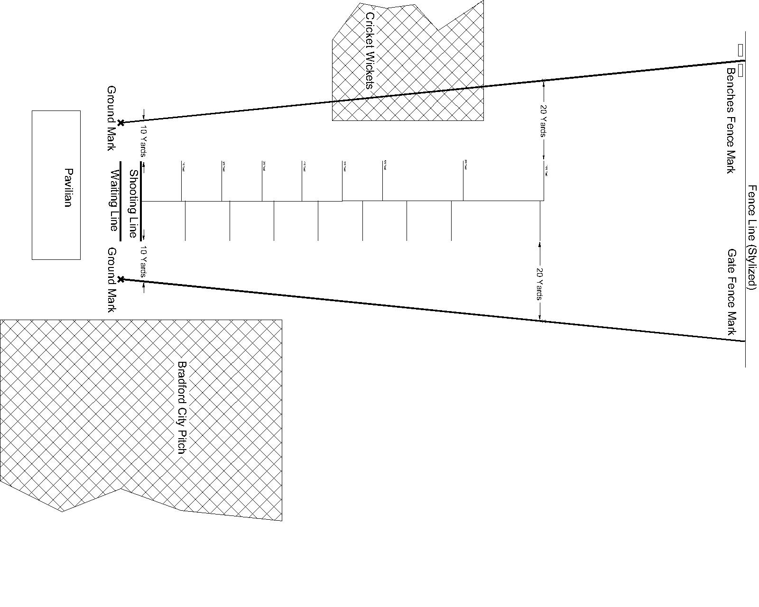
Set up
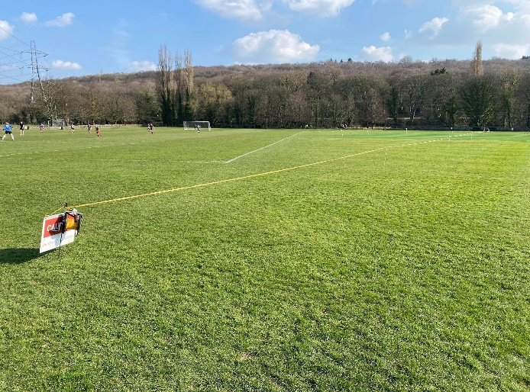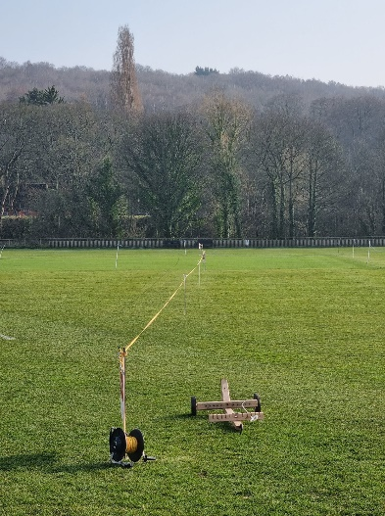
Cricket side
- Start by putting the large black spike into the white cross.
- Walk towards the white mark between the benches at the fence end of the field. 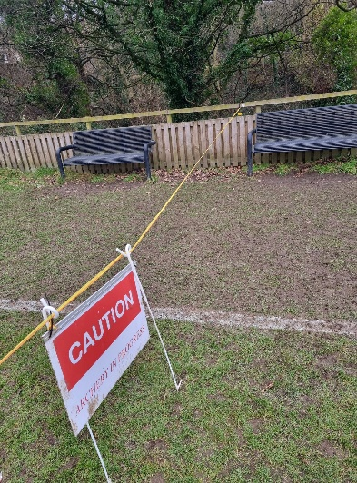
- Spike out with the pigtail spikes as needed to hold the rope.
- Use 2 pigtails where a sign is required.
- Put a pigtail close to the cricket square boundary. 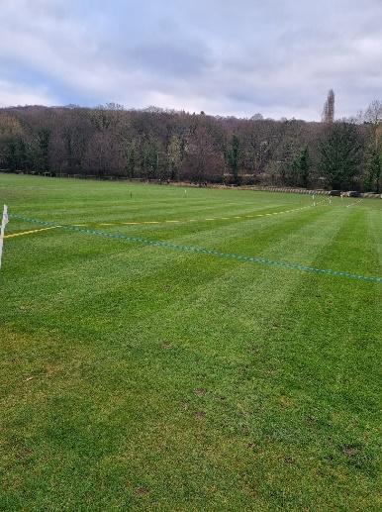
- Walk around the square.
- Place another pigtail close to the square boundary closest to the fence. 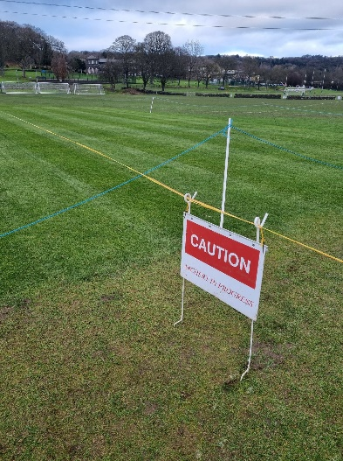
- Continue to spike out towards the mark between the benches.
- Attach rope to the fence at the mark. 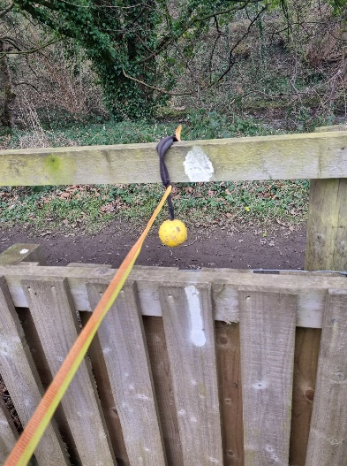
- Leave rope trolley near the fence.
- Walk back to the shooting line with the rope reel, connecting the rope to pigtail spikes. Looping through once is sufficient.
- Again walk around the cricket square, lifting the rope over the boundary.
- Continue connecting the rope to the pigtail spikes. 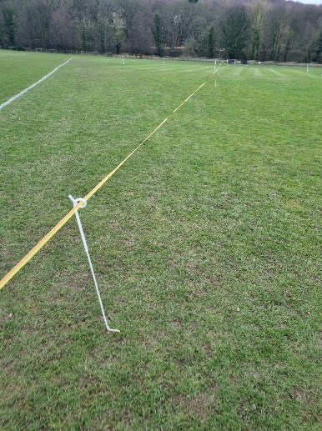
- Pull the rope tight and tie around the black spike.
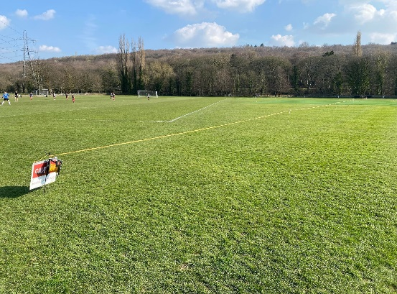
Football 1st team side
- Start by putting the large black spike into the white cross.
- Walk towards the white mark on the fence to the right of the gate. 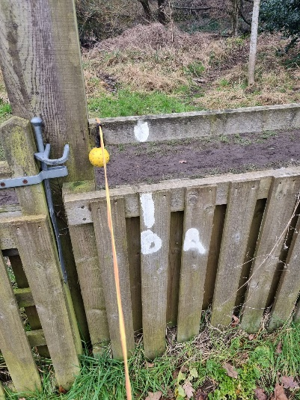
- Spike out with the pigtail spikes as needed to hold the rope.
- Use 2 pigtails where a sign is required.
- Attach rope to the fence at the mark.
- Leave rope trolley near the fence.
- Walk back to the shooting line with the rope reel, connecting the rope to pigtail spikes. Looping through once is sufficient.
- Pull the rope tight and tie around the black spike.

Take down
- Wind the rope in as you walk towards the fence, (leaving the rope attached to the fence) and unhooking from the pigtail spikes as you walk.
- Put the reel on the rope trolley, walk back to the shooting line collecting the spikes and signs.
- Put signs into the big hook about ¾ of the way down and the ropes for them over the two hooks at the sides.
- Put the spikes in the holes across the top and bottom.

If on the cricket side walk around as with setting up.

