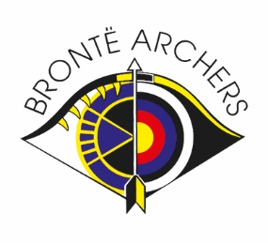Bronte Archers New Year Single Clout Results
NAME | HITS | SCORE | CLOUTS

80yds
Junior Lady Barebow
Amy Kemp | 15 | 39 | 0

Lady Barebow
Caron Kolowiecki | 7 | 23 | 1

120yds
Gent Barebow
Gary Kemp | 14 | 29 | 0

Lady Recurve
Barbara Smith | 10 | 22 | 1

140yds
Lady Recurve
Deborah Waterhouse | 8 | 28 | 2
Rosemary Fell | 5 | 7 | 0

180yds
Lady Recurve
Shelley Hurst | 29 | 76 | 3

Gent Recurve
Matthew David | 32 | 88 | 4
Matthew Beville | 20 | 40 | 0

Gent Compound
Neil Crickmore | 36 | 134 | 9
Iain Potts | 29 | 69 | 1
Julian Smith | 14 | 41 | 1
Darren Clarkson | 13 | 27 | 0

Gent Barebow
Kevin Schofield | 11 | 24 | 0
Simon Coates | 13 | 20 | 0
Paul Steenson | 5 | 8 | 0
Steve Kolowiecki | 3 | 7 | 0
Alan Smith | 3 | 6 | 0
Gent Longbow
John Fell | 1 | 1 | 0

