Covid-19 Return to shooting from August 25th 2021
Important: For archers wishing to shoot outdoors
When booking to shoot you are agreeing that you will abide by ALL the control measures within the Risk Assessment and will follow the guidance the club committee has put in place below.
A maximum of 2 archers per boss from different households/ 1 family per boss from same household.
All archers who wish to shoot on the same boss must agree the distance they wish to shoot.

Indoor Range use is permitted (see separate guidance and risk assessments.
The Referee Changing Room Toilet facilities, Pavilion kitchen and toilets are available
Referee changing room toilet use remains available. Use of pavilion toilets and kitchen are now allowed. Access is currently through the indoor range. It is the responsibility of each member to manage the hygiene and cleanliness of facilities. Cleaning spray and kitchen rolls are available in container and indoor range. Contact points should be sanitised after use. Hands should be washed and sanitised before and after use. It is recommended to wear face masks, covering nose and mouth.
Booking:
To comply with government regulations a booking system is in place. You MUST book on a session, there is no turn-up and shoot. The booking form is available online here: https://bronte-archers.co.uk/booking-form/
Please complete ONE FORM PER BOSS. If you complete one form for two archers this means you have agreed to share a boss prior to booking. If you complete a form for yourself only then you will be on your own boss. You can not change who you’re sharing with after arriving at the range. You must not attend the club without an approved booking.

ALL ARCHERS MUST BRING THEIR OWN WASTE BAG AND TAKE HOME ALL THEIR USED GLOVES & FACE COVERINGS
PPE Equipment provided by the Club: (if you can provide your own, please do)
On arrival at the range for your session
All archers must set up/take down your archery equipment keeping a safe distance away from all other persons.
If you are the 1st to arrive do not start setting up alone, wait for another archer to arrive.
Just a few points to remember:
Only 2 persons at any one time in the container (socially distanced where possible)
Face masks recommended to be worn inside the container, hands sanitised and wear the disposable gloves provided.
If a family/couple from the same household are setting up, face coverings are not needed but all must sanitise and wear the disposable gloves provided.
Important: You MUST sign in completing the following; time of arrival, your name and time of leaving. Signing in/out book will be placed on the back of the container door (archers must use their own pen)
Maximum of 9 bosses placed 2.5 metres apart; ensuring the entirety of the boss fits within the painted white lines. 1 small bottle of sanitiser must be placed safely with each boss (tucked behind the stand leg) these will be provided by the club. Face masks can be removed once outdoors but if you feel more comfortable wearing one then please do so when not actively shooting.
Please rope out the side safety areas correctly! The illustration below shows the correct measurements to use; From the outer edge of bosses, the distance from the shooting line is 10-yards increasing to 20 yards at the 60-yard distance and 25-yard at the 100-yard distance, then follow that angle all the way to the fence. There is a white cross near the waiting line and a white marking on the fence for the pre measured start and end points of the side safety areas.
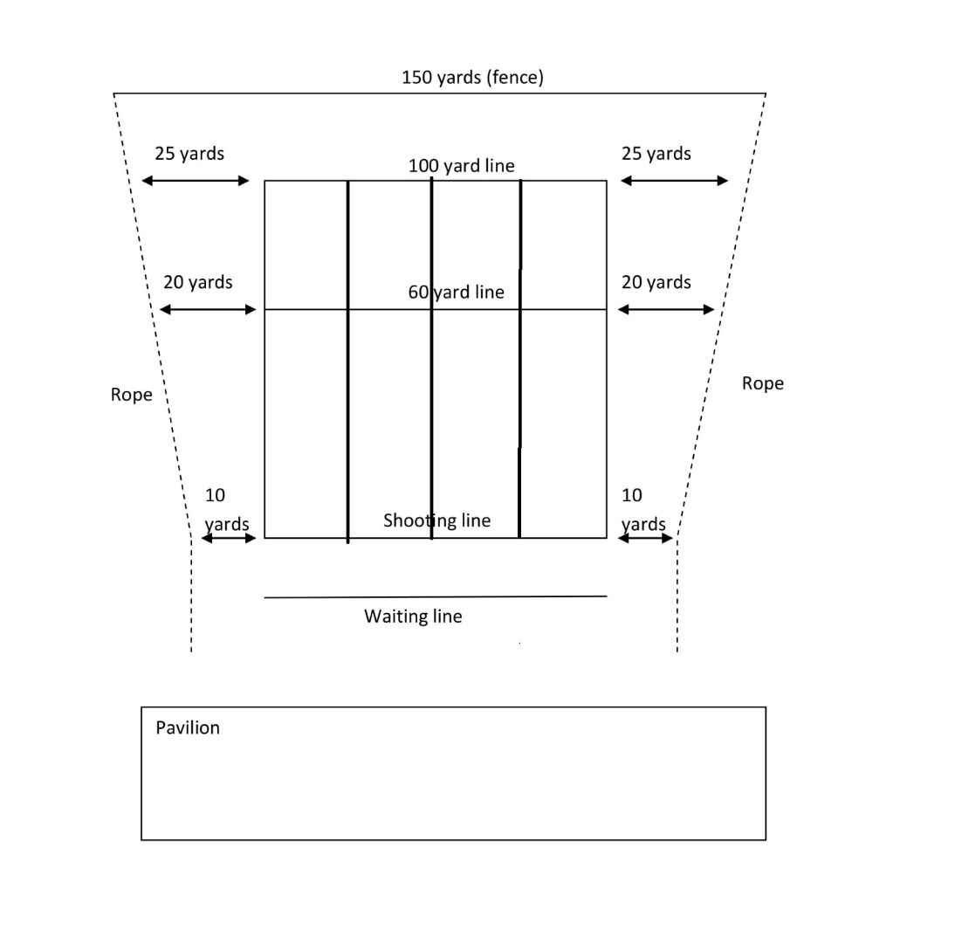
Please start shooting at a short distance to minimise chances of missing the target!
On completion of setting the required amount of bosses onto the range
Distance yourselves 2 metres apart if possible, if not, then the 1+ metre will apply when not on the shooting line.
Follow the rules of shooting, nominate a field captain (usually the archer shooting the longest distance but can be anyone) and enjoy your session whilst socially distancing at all times.
Lost Arrows
If you miss the target and lose an arrow/s you must stay within the lines of your lane and try to keep 2 metres away from other archers until arrow is found. If the arrow/s isn’t found before you leave, please let everyone who is present know and complete the “Lost Arrow” sheet.
Taking down the range
Once all equipment is back in the container, including the toilet key, sign out, close and padlock the door before removing your gloves. Gloves and face covering MUST be put into your own waste bag and disposed of once you arrive home.

