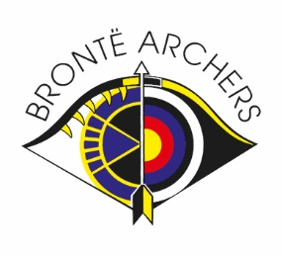Bronte Archers Club Clout Champs Results
100yds
Lady Recurve
Barbara Smith | 33 | 16 | 0

Gent Recurve
Lewis Broadbent | 55 | 29 | 0

120yds
Gent Barebow
Gary Kemp | 69 | 32 | 0

Gent Compound
Julian Smith | 69 | 30 | 0

140yds
Lady Recurve
Shelley Hurst | 157 | 57 | 2
Li Caswell-Sou | 78 | 35 | 0

180yds
Gent Recurve
Darren Clarkson | 147 | 64 | 0
Matthew David | 87 | 36 | 2

Gent Compound
Iain Pots | 108 | 44 | 2

Gent Barebow
Alan Smith | 24 | 15 | 0

